Stephen Arnold
Phone number: +44 7539901671
Email: stephenarnolddev@gmail.com
Portfolio: https://stephenarnolddev.com/portfolio/

Personal Profile:
Enthusiastic and reliable London based programmer that specialises in game development and technology, who has created several 2D and 3D prototypes for various platforms including mobile phones and computers. A communication hero who has worked autonomously in both team and solo developed games with experience at all stages of development within an Agile environment. Key knowledge in working with game engines: Unity and Unreal, understanding their principles and adapting to their methodology. Continuously learning and improving from research and peers.

Skills:
- Programming with C#, C++, Java, Python, Javascript, PHP and Lua.
- Experience with Unity, Unreal, Android Studio, Gamemaker Studio and Flash.
- Published titles to the google play store and itch.io.
- Other tools used include: Git, Visual Studio, Atom, Maya, Blender, Trello, and other core development software.
- Creative problem-solving approach in a fluid, flexible and continuously evolving environment.
- Team leadership experience in various small teams.

Education:
- Computer Games Programming BSc (Hons), Kingston University, 2018 – 2021
  - Expected Grade: 1st
- 3 A levels in Mathematics, Physics and Chemistry and an AS level in Computing
- 10 GCSEs including English, Maths and Science

Extracurricular:

2019-2021, Various Gamejams
-Participated and won awards in several gamejams hosted in person around Kingston and online. Participating in teams in various roles from lead programmer, game designer and content creator. Details for each can be found on the full portfolio.

2018-2019, Module Co-ordinator, CoderDojo Ham
-Head of a voluntary monthly course that taught children aged 7-17 to code games online.

Experience:

2019 – 2021, University Mentor and Department of Networks & Digital Media worker, Kingston University
-Working as a mentor in the computer science department of Kingston university. Acting as an assistant to newer students on my course to understand the lessons and general assisting with programming. Also working as a teaching assistant to one of the first-year modules within my course.

2019 April - September, Sales Assistant, Office Wandsworth
-Sales assistant to the shop, organising the shop floor, selling featured brand products, and performing my required tasks while addressing the customers in a friendly manner.

Projects:
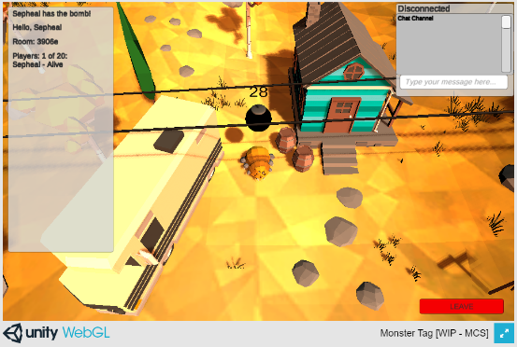 | Monster Tag – 2021  3D multiplayer action game for windows and browsers.  Role: Programmer  Team size: 3 people  Development time: 2 weeks  Technology: Unity with C# & PhotonNetwork
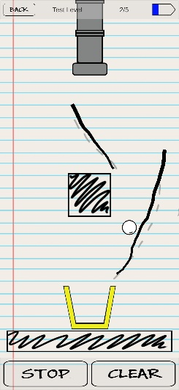 | Draw-fall – 2020  2D puzzle game for Android, which was being mentored by Juliet Colman from King.  Role: Lead Programmer  Team size: 3 people  Development time: 3 months  Technology: Unity with C#
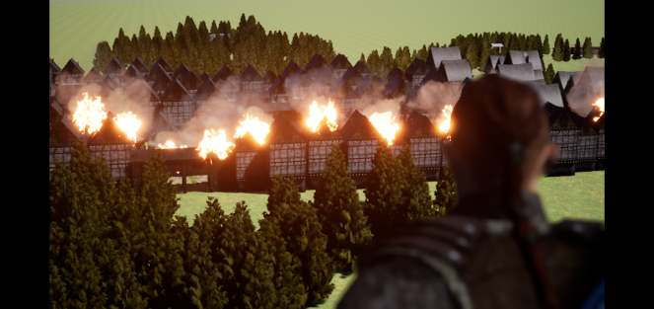 | World of Alteria - 2021  3D Narrative turn based RPG for PC.  Role: Gameplay programmer  Team size: 3 people  Development time: 2.5 months  Technology: Unreal with C++

References: Available on request

